tmTNF biosynthesis
TNF/TNF-alpha biosynthesis (tmTNF)
*All text in this color is our own notes we have added for clarity. For in depth information about TNF, please refer to Task 702: sTNF documentation file.
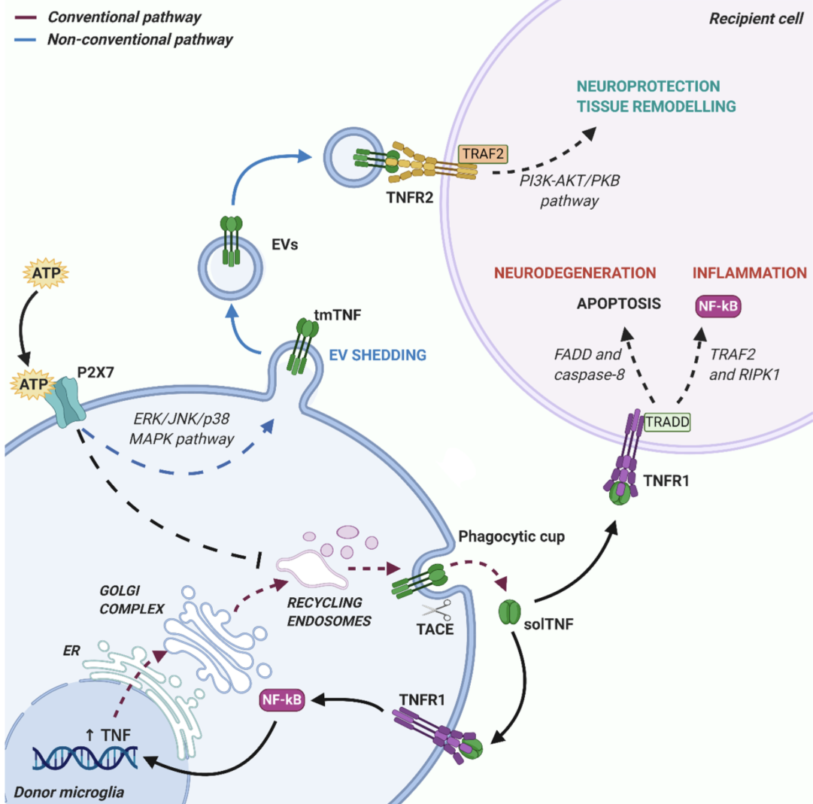

For the unconventional release pathway of tmTNF, it is unclear how tmTNF is actually made (since it differs from sTNF which is processed and packaged in the ER and golgi, has a pro domain that later gets cleaved, is trimerized, etc.). For the purpose of the biosynthesis pathway, we used mature tmTNF as a starting point, and from there elaborated on the later steps. To start this task, a fake reaction is needed. The fake metabolites are : tmTNF1[c] and tmTNF2[c].

Reaction: tmTNF-1[c] → tmTNF-2[c]

**Please refer to the clarification note in the short notes.

- tmTNF packaging into autophagosomes
The non-conventional release pathway (blue lines in figure above) instead consists in tmTNF membrane localization via an ER—Golgi independent route, avoiding post-translational modifications. In this case, bearing outside of the phagocytic cup and distant from TACE enzymes, tmTNF is protected from cleavage and can be packed into shedding EVs.
Source: https://www.mdpi.com/2073-4409/9/10/2145

The well-developed paradigm of conventional protein secretion through the ER, Golgi and post-Golgi trafficking (right arrow) versus the process (left arrow) of autophagy-dependent unconventional secretion of cytosolic proteins (secretory autophagy). The proteins destined for conventional secretion enter ER via signal peptides, whereas cytosolic proteins destined for secretory autophagy are sequestered into autophagosomes to be exported from the cell.
Source:https://www.researchgate.net/figure/Protein-secretion-conventional-biosynthetic-pathway-versus-unconventional-secretion_fig2_235749276
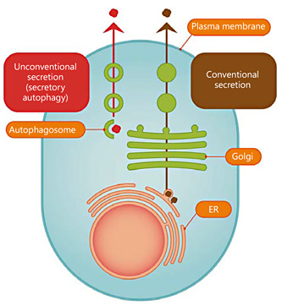

Morphologically, autophagy starts with the nucleation of the phagophore, the initial sequestering organelle. Upon autophagy induction, ATG14, an autophagy-specific member of the phosphatidylinositol 3-kinase complex, is rapidly recruited to the phagophore where it plays a role in early steps of autophagosome biogenesis. Under autophagic conditions, ATG14 and phosphatidylinositol-3-phosphate are enriched in specific ER subdomains from which cup-shaped structures called omegasomes emerge (Axe et al., 2008). As these compartments are positive for components of the autophagic machinery, it was proposed that omegasomes constitute the platform for autophagosome formation.
Source: https://pmc.ncbi.nlm.nih.gov/articles/PMC3668556/
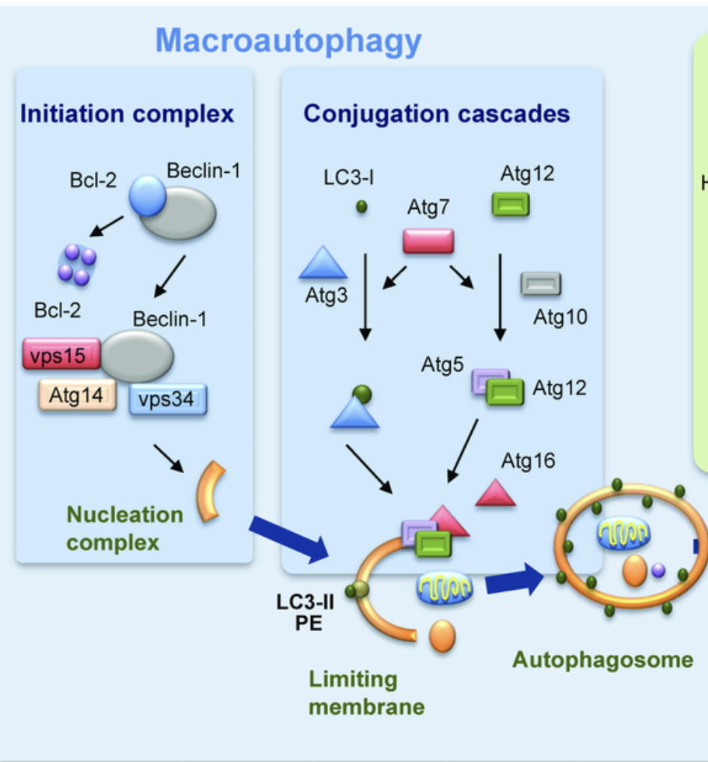
Source: https://www.researchgate.net/figure/Molecular-components-of-mammalian-autophagic-pathways-Scheme-of-three-different-types-of_fig1_51087599

Beclin 1, the mammalian orthologue of yeast Atg6, has a central role in autophagy, a process of programmed cell survival, which is increased during periods of cell stress and extinguished during the cell cycle. It interacts with several cofactors (Atg14L, UVRAG, Bif-1, Rubicon, Ambra1, HMGB1, nPIST, VMP1, SLAM, IP3R, PINK and survivin) to regulate the lipid kinase Vps-34 protein and promote formation of Beclin 1-Vps34-Vps15 core complexes, thereby inducing autophagy.
Beclin-1 is a protein that in humans is encoded by the BECN1 gene.
Source: https://www.nature.com/articles/cdd2010191

Autophagy involved in this process is LC3-dependent (ULK1 independent) because it is crucial for the non-degradative process for packaging cargo into EVs, which is the case of non-conventional pathway of tmTNF in microglia.
LC3-dependent EV loading and secretion (LDELS) is a secretory autophagy pathway in which the macroautophagy/autophagy machinery facilitates the packaging of cytosolic cargos, such as RNA-binding proteins, into extracellular vesicles (EVs) for secretion outside of the cell. Here, we identify TFRC (transferrin receptor), one of the first proteins found to be secreted via EVs, as a transmembrane cargo of the LDELS pathway
Source: https://doi.org/10.1080/15548627.2022.2140557

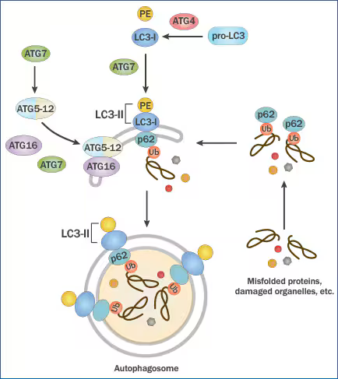
Atg4 cleaves pro-LC3 to form LC3-I which then gets conjugated to PE (by Atg7) for the generation of LC3-II. The latter gets recruited to the autophagosomal membrane for helping membrane elongation. ATG7 also mediates ATG5-ATG12-ATG16 complex formation and the latter along with LC3-II is highly critical for autophagosome formation. Adaptor protein p62/SQSTM1 binds to ubiquitinated proteins and LC3-II for mediating autophagy via localizing into autophagic compartments, transporting ubiquitinated proteins and organelles for degradation.
Source: https://www.novusbio.com/support/faqs-autophagy-and-lc3?srsltid=AfmBOorYyTEYpY2k10iWfIhNLd3gWpN-GFUckX_v_cdwePoron9Hz-XY

GENES INVOLVED:
BECN1: key gene involved in autophagosome membrane formation and regulation of autophagy
Source: https://www.sciencedirect.com/topics/biochemistry-genetics-and-molecular-biology/becn1

MAP1LC3B: gene for LC3

ATGA16L1 or ATG16L2: The results also showed that Atg16L2 is unable to compensate for the function of Atg16L1 in autophagosome formation, and knockdown of endogenous Atg16L2 did not affect autophagosome formation, indicating that Atg16L2 does not possess the ability to mediate canonical autophagy. Source: https://pmc.ncbi.nlm.nih.gov/articles/PMC3288023/

Gene name | Ensembl ID | Main transcript
BECN1 | ENSG00000126581 | ENST00000590099.6
ATG4B | ENSG00000168397 | ENST00000404914.8
ATG5 | ENSG00000057663 | ENST00000369076.8
ATG10 | ENSG00000152348 | ENST00000282185.8
ATG12 | ENSG00000145782 | ENST00000509910.2
ATG14 | ENSG00000126775 | ENST00000247178.6
ATG16L1 | ENSG00000085978 | ENST00000392017.9
MAP1LC3B | ENSG00000140941 | ENST00000268607.10
SQSTM1 | ENSG00000161011 | ENST00000389805.9
Reaction: tmTNF-2[c]→tmTNF-2[a]
Where a is autophagosome

- Packaging of tmTNF in vesicles

SNAP23 gene ( https://www.uniprot.org/uniprotkb/O00161/entry ): gene crucial for membrane fusion
Stx4 gene: Plasma membrane t-SNARE that mediates docking of transport vesicles
10.3389/fimmu.2014.00538:
Transmembrane TNF (tmTNF) is incorporated into Golgi-independent vesicular carriers originating from recycling endosomes and plasma-membrane–derived compartments. Vesicle formation and cargo sorting are mediated by ARF6-dependent membrane remodeling and Rab GTPase–controlled trafficking. tmTNF-containing vesicles are transported along the actin cytoskeleton and assembled into fusion-competent carriers through non-neuronal SNARE complexes, primarily composed of VAMP3, syntaxin-4 (STX4), and SNAP23, enabling delivery of tmTNF to the cell surface or its incorporation into microvesicles.

Reaction: tmTNF-2[a] → tmTNF-2[v]
Where v is vesicle.
Gene name | Ensembl ID | Main transcript
ARF6 | ENSG00000165527 | ENST00000298316.7
RAB11 | regulator
RAB6 | regulator
RAB37 | regulator
VAMP3 | ENSG00000049245 | ENST00000054666.11
STX4 | ENSG00000103496 | ENST00000313843.8
SNAP23 | ENSG00000092531 | ENST00000249647.8
SCAMP5 | Potential regulator

VAMP3, STX4 and SNAP23 are non-neuronal SNAREs involved in vesicle fusion events from recycling endosomes to the plasma membrane.
“Adaptor proteins regulate sorting of membrane proteins and the AP-I complex has been implicated in both phagocytosis and the trafficking of TNF from the recycling endosome (24). Typically, AP complexes recruit the coat protein clathrin to vesicles for their formation, but this is not the case during phagocytosis where AP-1 decorated endosomes amass below the phagocytic cup in an ARF-1-dependent, clathrin-independent manner (24). Depletion experiments suggest that AP-1 might act to sort TNF at the recycling endosome and a cleaved form of AP-1 accompanies carriers that bud off the recycling endosome to the surface for VAMP3- and ARF6-dependent delivery at the tips of pseudopodia during phagocytosis (54, 55).” (source: 10.3389/fimmu.2014.00538)

Rab6, Rab11, Rab37: regulators of TNF delivery
“The p230-labaled TNF carriers are also regulated by Rab6 and Rab6a′, which act to stabilize Arl1-recruited p230 on TGN membranes
Two Rab GTPases, Rab11 and Rab37, have been found to regulate surface delivery of TNF (11, 16) and these Rabs are also upregulated after LPS activation of cells.”

SCAMP5:
SCAMP5 has the potential to regulate SNAREs at multiple points in the TNF secretory pathway and can form complexes with many of the SNAREs (Stx4, Stx6, SNAP23, and VAMP3) identified at the different stages of TNF secretion (21). In the absence of stimulus, SCAMP5 localizes predominantly to the Golgi complex along with Stx6 and after stimulation with ionomycin shifts to the recycling endosome and cell surface, where it colocates with Stx4/SNAP23 (21). This shift in localization occurs in parallel to TNF secretion (21). Although SCAMP5 forms a complex with SNARE proteins, this binding is not direct and occurs through the calcium binding transmembrane synaptotagmins (Syt) (21). Loss of the synaptotagmin-binding site in SCAMP5 inhibits ionomycin induced TNF secretion (21). SCAMP5 binds at least two synaptotagmins, Syt1 and Syt II, but their role in TNF has yet to be established.

Syntaxin 6 and Vti1b: 10.1074/jbc.M414420200
A key function of activated macrophages is to secrete proinflammatory cytokines such as TNFalpha; however, the intracellular pathway and machinery responsible for cytokine trafficking and secretion is largely undefined. Here we show that individual SNARE proteins involved in vesicle docking and fusion are regulated at both gene and protein expression upon stimulation with the bacterial cell wall component lipopolysaccharide. Focusing on two intracellular SNARE proteins, Vti1b and syntaxin 6 (Stx6), we show that they are up-regulated in conjunction with increasing cytokine secretion in activated macrophages and that their levels are selectively titrated to accommodate the volume and timing of post-Golgi cytokine trafficking. In macrophages, Vti1b and syntaxin 6 are localized on intracellular membranes and are present on isolated Golgi membranes and on Golgi-derived TNFalpha vesicles budded in vitro. By immunoprecipitation, we find that Vti1b and syntaxin 6 interact to form a novel intracellular Q-SNARE complex. Functional studies using overexpression of full-length and truncated proteins show that both Vti1b and syntaxin 6 function and have rate-limiting roles in TNFalpha trafficking and secretion. This study shows how macrophages have uniquely adapted a novel Golgi-associated SNARE complex to accommodate their requirement for increased cytokine secretion.

GPR: ARF6 AND VAMP3 AND STX4 AND SNAP23
Regulators: RAB6, RAB11, RAB37, SCAMP5

- P2X7 receptor–mediated EV formation (positive feedback loop)

ATP-mediated activation of P2X7 receptors on donor microglial cells is able to influence these mechanisms, inhibiting the conventional release pathway and favoring non-conventional TNF release into EVs. Several routes for unconventional cytokine secretion have been described. These include cytokine interaction with the lipid membrane and formation of a permeable pore, membrane transporter routes [55] or cell death through pyroptosis.

Gene name | Ensembl ID | Main transcript
P2RX7 | ENSG00000089041 | ENST00000328963.10

Reaction: tmTNF-2[v]→tmTNF-2[rP]
Where rP is receptor P2RX7.

GPR rules: P2RX7

- Interaction of tmTNF with TNFR2 or TNFR1
EV-carried tmTNF preferentially interacts with TNFR2 receptors (also known as TNFRSF1B, CD120b) on target cells, triggering protective responses.
Source: https://www.mdpi.com/2073-4409/9/10/2145
Indeed, although both TNF receptors bind soluble TNF with high affinity only TNFR1 becomes readily activated by soluble TNF [Citation 24]. In contrast, membrane TNF strongly activates TNFR1 and TNFR2 [Citation 24].
Source: https://www.tandfonline.com/doi/full/10.1080/14728222.2019.1586886#d1e374

Gpr Rules: TNFRSF1A OR TNFRSF1B

Gene name | Ensembl ID | Main transcript
TNFRSF1A | ENSG00000067182 | ENST00000162749.7
TNFRSF1B | ENSG00000028137 | ENST00000376259.7

Reaction: tmTNF-2[v]→tmTNF-2[r]

Where r is either receptor TNFRSF1A or TNFRSF1B.

Short notes
- Clarification note: The unconventional secretion pathway of tmTNF is not fully resolved in the literature and does not fit cleanly into existing Type I-IV unconventional secretion classifications. In this task, autophagosome-associated mechanisms were included to represent reported LC3-dependent and vesicle-associated trafficking steps described for tmTNF release. However, it is still up for interpretation whether this is the case, or if instead, tmTNF is packaged directly into Golgi-independent vesicular carriers and extracellular vesicles. Due to limited and partially overlapping literature, the autophagosome-related steps were retained in this task, and this uncertainty is discussed in more detail in the report.

Non-conventional pathways
- Mediate release proteins lacking leader sequences
- Not sure how tmTNF that remains tmTNF is produced before getting released, since it is ER and Golgi independent.
- Allows cells to secrete cytokines with PTMs
- Protects host when conventional mechanisms are compromised (e.g. under ER stress)
- Consists of formation + shedding of membrane vesicles at cell surface or vesicle budding inside endosomal compartments
- Although TNF has a signal peptide, it can also be released through unconventional vesicular pathways with extracellular vesicles
Source: https://www.mdpi.com/2073-4409/9/10/2145
- Not sure if Rab should be included as they are regulators
- The non-conventional secretory pathways typically mediate release of proteins lacking leader sequences, through an ER-Golgi transport-independent mechanism. Unconventional secretion allows cells to secrete cytokines without the requirement for post-translational modification Source: https://www.mdpi.com/2073-4409/9/10/2145

